**Get a Free Trial Account on SAP Cloud Platform**

Sign up for a free trial account on SAP Cloud Platform.

#### You will learn

* How to register on the SAP website
* How to “upgrade” your account (at no cost) for the SAP Cloud Platform trial

Step 1: Log into the SAP website

At the upper-right corner of this tutorial page (or any page on [**www.sap.com**](https://www.sap.com/)), click the **Log On** icon.

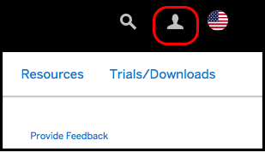

If you have an account on [**www.sap.com**](https://www.sap.com/) (e.g. an S, C, D or I number) you can enter it or the associated email along with your password. If you don’t have an account yet, you can select one of the other login methods or click **Register** to create an account.

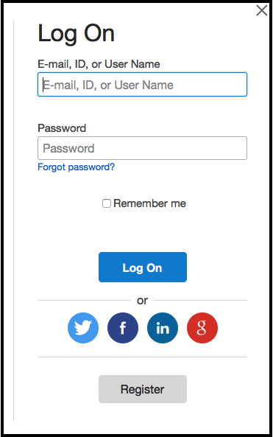

If you don’t need to register with sap.com, you can skip to Step 4.

Step 2: Register at sap.com

If you clicked **Register** in the previous step, you will see a **Register dialog**. Fill in the required fields, and click **Register**.

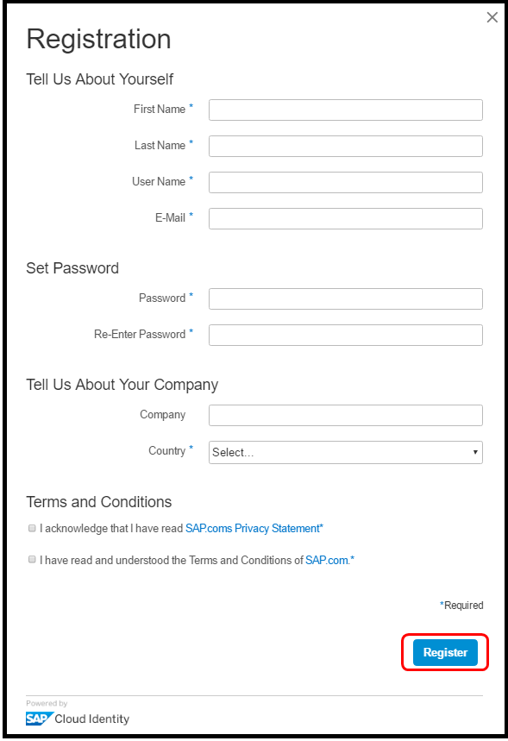

You will get a message that an activation link has been sent to you.

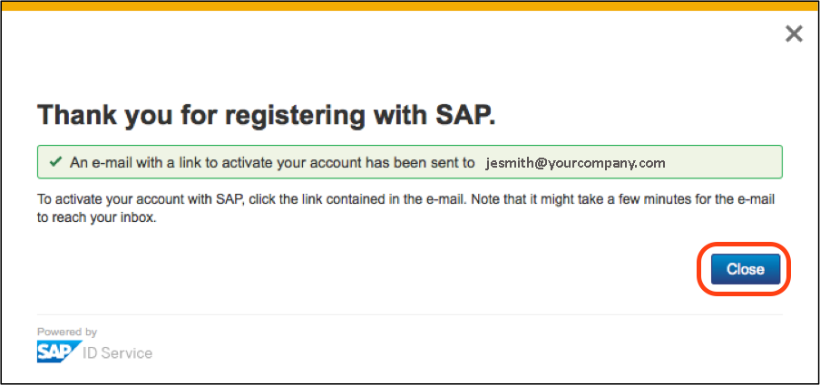

Step 3: Activate your account

Once again in the upper-right corner of this tutorial page (or any page on [**www.sap.com**](https://www.sap.com/)), click **Log On**.

Enter the same credentials you used to log into the sap.com website.

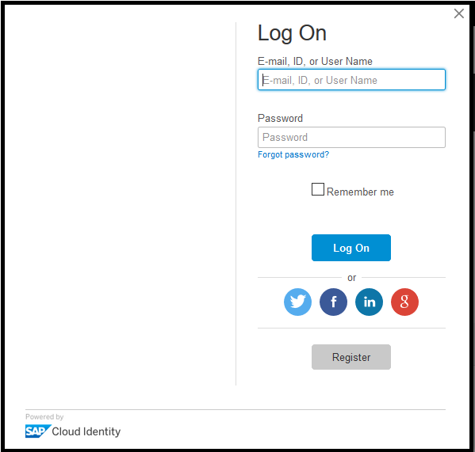

If you have just registered in the step above, you may get a log-in error until you activate your account via the email link sent.

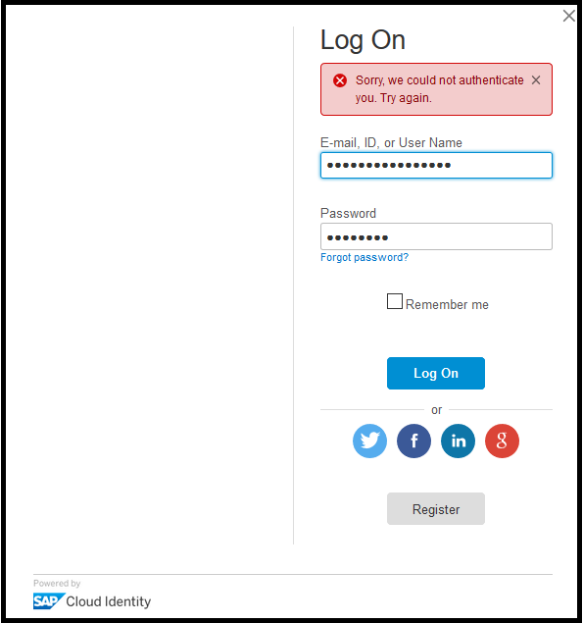

After activating your account, you will see the following screen. Click **Continue**.

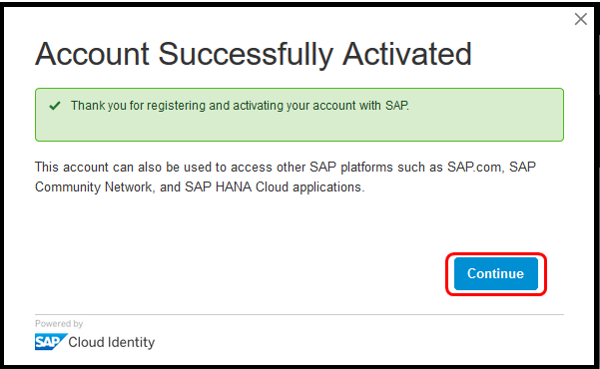

Step 4: Upgrade your SAP.com registration

After activation, or if you already had an SAP account, go to the [**SAP Cloud Platform Trial**](https://account.hanatrial.ondemand.com/)(<https://account.hanatrial.ondemand.com/>) page and click **Log On**.

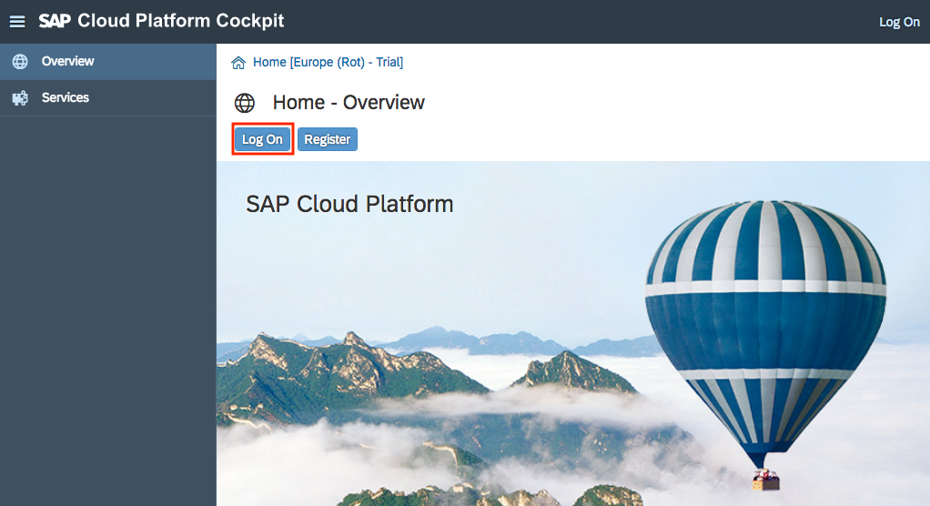

Assuming you don’t already have an SAP Cloud Platform trial account, you will see an **Upgrade your account for SAP.com** dialog. If so, fill out all fields and click **Register**. This simply adds the SAP.com registration to your login account on SAP Cloud Identity. There is no cost associated with this registration.

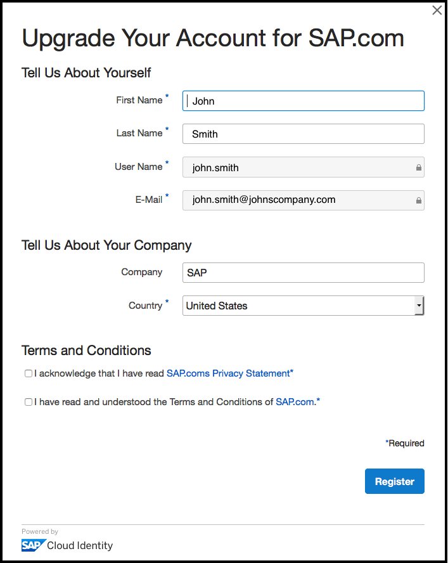

Step 5: Access the SAP Cloud Platform cockpit

Once you have accepted the Terms and Conditions and registered, the SAP Cloud Platform **Regions** page will load.

Click the ***Neo Trial*** tile to access your free personal trial account.

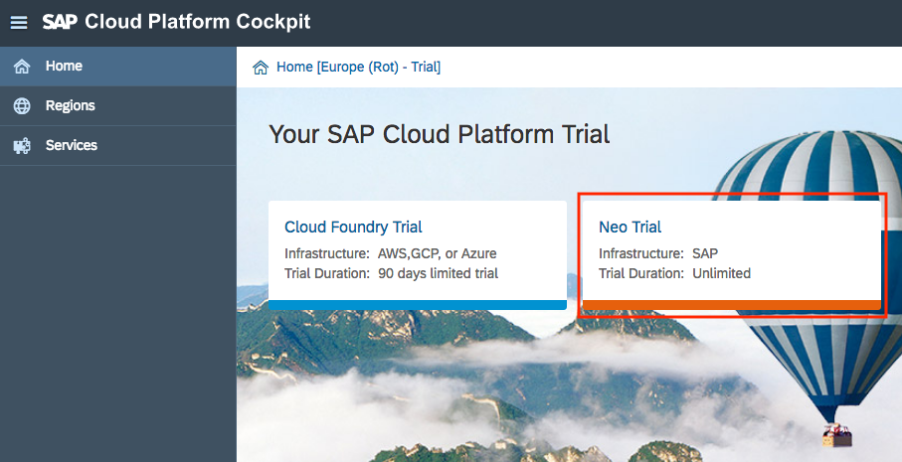

You can then review the latest ***News and Announcements***.

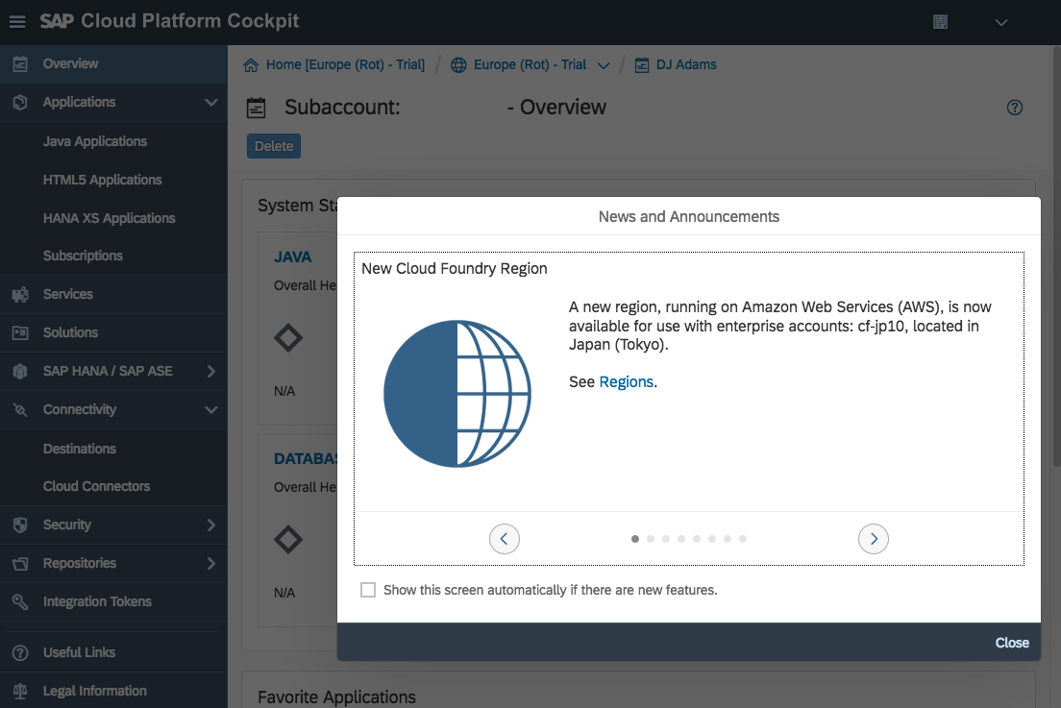

Step 6: Validate the SAP Cloud Platform cockpit URL

Close the **News and Announcements** dialog box.

Copy the URL for your SAP Cloud Platform **Personal Trial Account** cockpit, and paste it in the text field below, and then click **Validate**.

